IMPLEMENTATION OF MOVIE RECOMMENDATION SYSTEM

FRONTEND
LOGIN
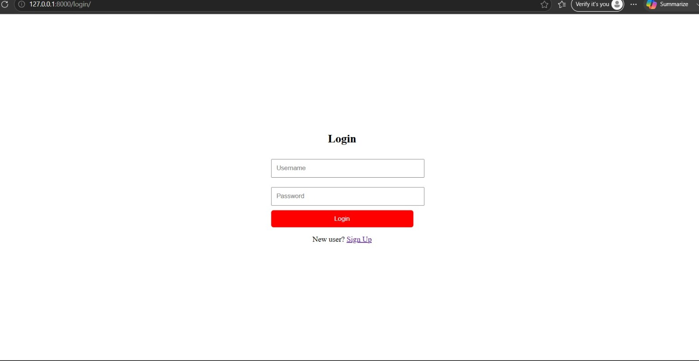
CODE
<!DOCTYPE html>
<html>
<head>
<title>Login</title>
</head>
<body>
<body style="margin:0; height:100vh; display:flex; justify-content:center; align-items:center;">
<div>
<h2 style="text-align:center;">Login</h2>
<form method="POST" style="width:300px; margin:auto;">
{% csrf_token %}
<input type="text" name="username" placeholder="Username"
style="width:100%; padding:10px; margin:10px 0;">
<input type="password" name="password" placeholder="Password"
style="width:100%; padding:10px; margin:10px 0;">
<button style="
width:100%;
padding:10px;
background:#ff0000;
color:white;
border:none;
border-radius:5px;
cursor:pointer;">
Login
</button>
</form>

SIGNUP
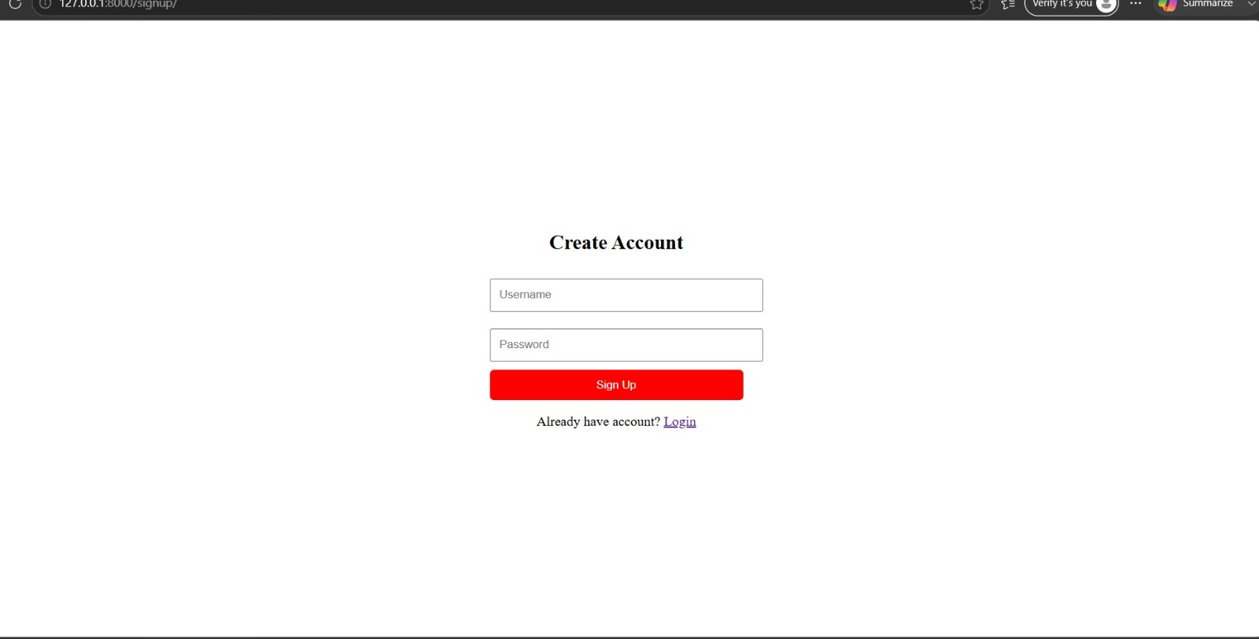
CODE
<!DOCTYPE html>
<html>
<head>
<title>Signup</title>
</head>
<body style="margin:0; height:100vh; display:flex; justify-content:center; align-items:center;">
<div>
<h2 style="text-align:center ; ">Create Account</h2>
<form method="POST" style="width:300px; margin:auto; ">
{% csrf_token %}
<input type="text" name="username" placeholder="Username"
style="width:100%; padding:10px; margin:10px 0;">
<input type="password" name="password" placeholder="Password"
style="width:100%; padding:10px; margin:10px 0;">
<button style="
width:100%;
padding:10px;
background:red;
color:white;
border:none;
border-radius:5px;
cursor:pointer;">
Sign Up
</button>
</form>
VIEW DETAILS
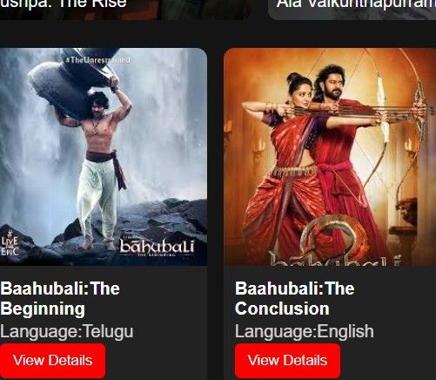
CLICK ON VIEW DETAILS YOU SEE MOVIE DETAILS
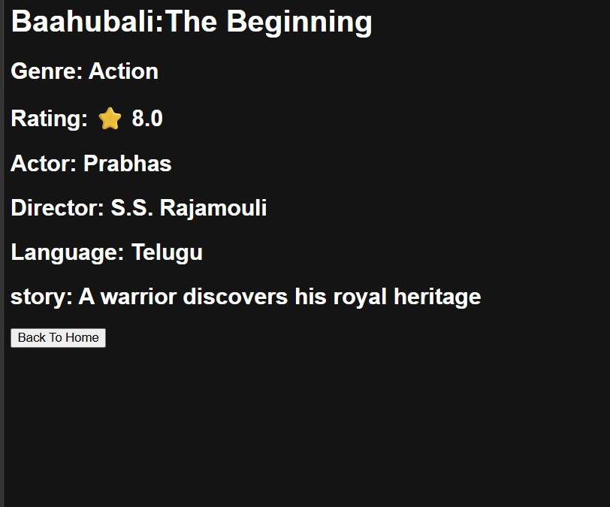
DOUBLE CLICK ON POSTER OPEN MOVIE TRAILER
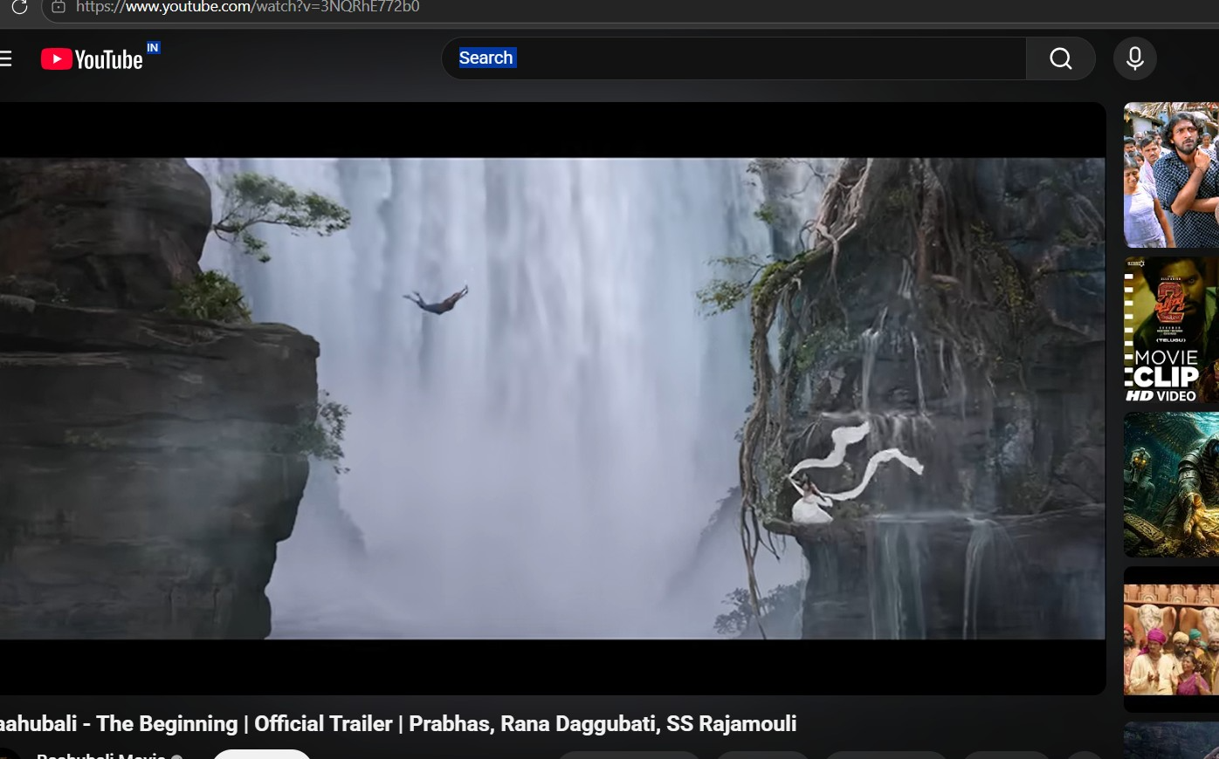
CODE
<!DOCTYPE html>
<html>
<head>
<title>movie name: {{ movie.title }}</title>
</head>
<body style="background:#141414; color:white; font-family:Arial;">
<h1>{{ movie.title }}</h1>
<h2>Genre: {{ movie.genre }}</h2>
<h2>Rating: ⭐ {{ movie.rating }}</h2>
<h2>Actor: {{ movie.actor }}</h2>
<h2>Director: {{ movie.director }}</h2>

<h2>Language: {{ movie.language }}</h2>
<h2>story: {{ movie.description }}</h2>
<a href="/">
<button>Back To Home</button>
</a>
</body>
</html>
HOMEPAGE
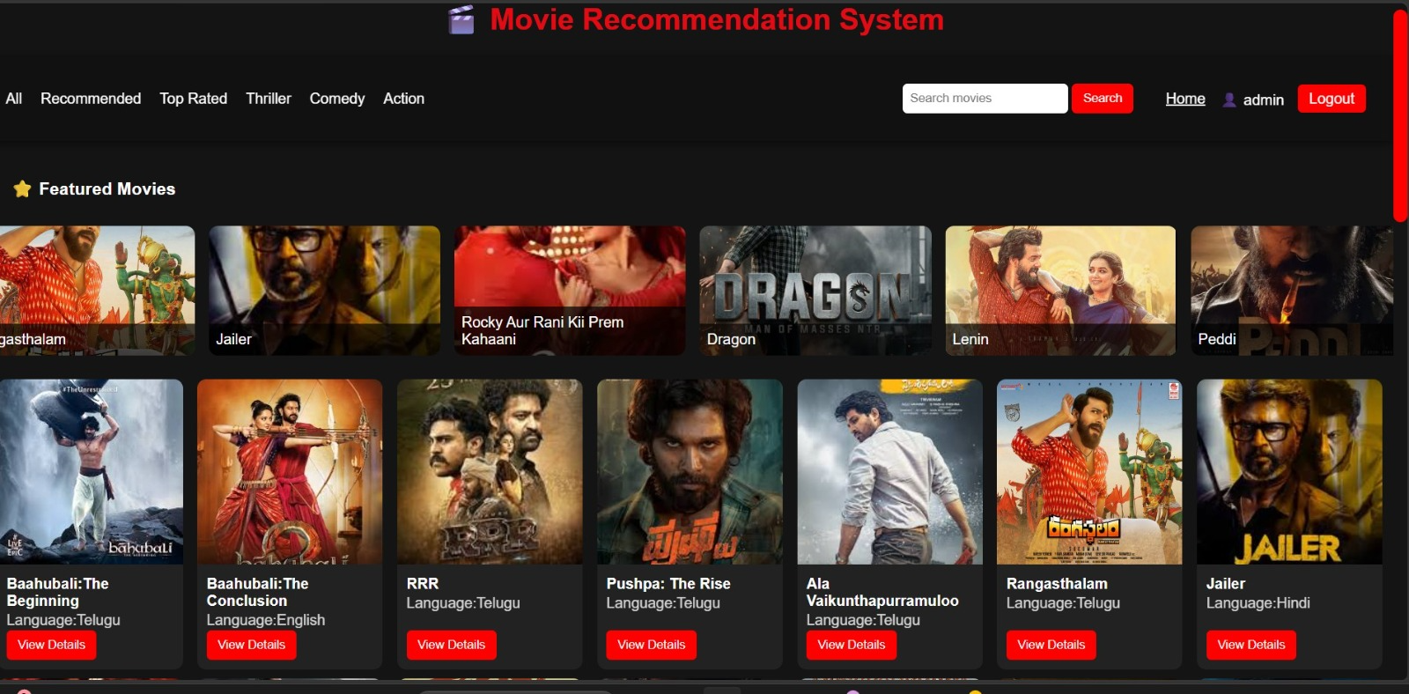
CODE
<!DOCTYPE html>
<html>
<head>
<title>Movie Recommendation System</title>
<style>
body{
margin:0;
}
::-webkit-scrollbar{
height:8px;
}
::-webkit-scrollbar-thumb{
background:red;
border-radius:10px;
}
</style>
</head>
<body style="background:#141414; color:rgb(255, 255, 255); font-family:Arial;">
<!-- STEP 1: TITLE -->
<h1 style="text-align:center; margin-top:23px; color:#e50914">
🎬 Movie Recommendation System
</h1>
<!-- STEP 2: NAVBAR (sticky added here) -->
<div style="
background:#111;
padding:15px;
display:flex;
gap:20px;
align-items:center;
margin-top: 8px;
position:sticky;
top:0;
z-index:1000;
box-shadow: 0 2px 10px rgba(0,0,0,0.6);
backdrop-filter: blur(10px);
">
<a href="/"
style="color:white; text-decoration:none;"
onmouseover="this.style.color='red'"
onmouseout="this.style.color='white'">
All
</a>
<a href="/?type=recommended"
style="color:white; text-decoration:none;"
onmouseover="this.style.color='red'"
onmouseout="this.style.color='white'">
Recommended
</a>
<a href="/?type=top"
style="color:white; text-decoration:none;"
onmouseover="this.style.color='red'"
onmouseout="this.style.color='white'">
Top Rated
</a>
<a href="/?type=thriller"
style="color:white; text-decoration:none;"
onmouseover="this.style.color='red'"
onmouseout="this.style.color='white'">
Thriller
</a>
<a href="/?type=comedy"
style="color:white; text-decoration:none;"
onmouseover="this.style.color='red'"
onmouseout="this.style.color='white'">
Comedy
</a>
<a href="/?type=action"
style="color:white; text-decoration:none;"
onmouseover="this.style.color='red'"
onmouseout="this.style.color='white'">
Action
</a>
<form method="GET" style="margin-left:auto;">
<input
type="text"
name="q"
placeholder="Search movies"
style="
padding:8px;
border-radius:5px;
border:none;
outline:none;
">
<button
type="submit"
style="
padding:8px 12px;
background:red;
color:white;
border:none;
border-radius:5px;
cursor:pointer;
">
Search
</button>
</form>
<div style="display:flex; align-items:center; background:#111; padding:15px;">
<!-- LEFT SIDE MENU -->
<a href="/" style="color:white; margin-right:15px;">Home</a>
<!-- RIGHT SIDE -->
<div style="margin-left:auto; display:flex; gap:15px; align-items:center;">
{% if user.is_authenticated %}
<!-- ACCOUNT SECTION -->
<span style="color:white;">
👤 {{ user.username }}
</span>
<!-- LOGOUT -->
<a href="/logout/" style="
background:red;
color:white;
padding:6px 12px;
border-radius:5px;
text-decoration:none;">
Logout
</a>
{% else %}
<!-- LOGIN -->
<a href="/login/" style="color:white;">Login</a>
<!-- SIGNUP -->
<a href="/signup/" style="
background:red;
color:white;
padding:6px 12px;
border-radius:5px;
text-decoration:none;">
Signup
</a>
{% endif %}
</div>
</div>
</div>
<h3 style="padding:20px 20px 10px 20px;">
⭐ Featured Movies
</h3>
<div id="featuredCarousel" style="
display:flex;
gap:15px;
overflow-x:hidden;
padding:0 20px 20px 20px;
scroll-behavior:smooth;
overflow-x: hidden;
">
{% for movie in movies|slice:":40" %}
<div style="
min-width:250px;
height:140px;
border-radius:10px;
overflow:hidden;
position:relative;
flex-shrink:0;
">
<img src="{{ movie.poster.url }}"
style="
width:100%;
height:100%;
object-fit:cover;
">
<div style="
position:absolute;
bottom:0;
left:0;
right:0;
background:rgba(0,0,0,0.7);
padding:8px;
">
{{ movie.title }}
</div>
</div>
{% endfor %}
</div>
<!-- STEP 3: MOVIE CARDS -->
<div style="
display:grid;
gap: 10px;
padding: 6px;
justify-content: flex-start;
grid-template-columns: repeat(auto-fill,minmax(180px,1fr));
scroll-behavior: smooth;
flex-direction: column;
flex: 1;
align-items: stretch;
">
{% for movie in movies %}
<div style="
flex: 0 0 180px;
background:#222;
border-radius:10px;
overflow:hidden;
display: flex;
flex-direction: column;
height: 100%; /KEY FIX/
width: 200px;
transition:transform 0.3s;
flex-shrink: 0;
"
onmouseover="this.style.transform='scale(1.05)'"
onmouseout="this.style.transform='scale(1)'">
<img src="{{ movie.poster.url }}"
ondblclick="openTrailer('{{ movie.trailer_url }}')"
style="width:100%; height:200px; object-fit:cover; cursor:pointer;">
<div style="padding:10px; display: flex; flex-direction: column; flex-grow:1 ;">
<h3 style="font-size: 16px; margin: 1.5px 0;">{{ movie.title }}</h3>
<p style="margin: 1.5px 0; opacity: 0.8;">Language:{{movie.language}}</p>
<a href="/movie/{{ movie.id }}/" style="margin-top: auto;">
<button style="
background: red;
color:white;
border:none;
padding:8px 12px;
border-radius:5px;
cursor:pointer;
">
View Details
</button>
</a>
</div>
</div>
{% endfor %}
</div>
<div id="player" style="
display:none;
position:fixed;
top:0;
left:0;
width:100%;
height:100%;
background:rgba(0,0,0,0.9);
z-index:9999;
">
<div style="width:80%; margin:5% auto;">
<span onclick="closeMovie()"
style="color:white; font-size:30px; cursor:pointer;">
✖️
</span>
<iframe id="videoFrame"
width="100%" height="450"
frameborder="0"
allowfullscreen>
</iframe>
</div>
</div>
<script>
const featured = document.getElementById("featuredCarousel");
// clone once for infinite loop
featured.innerHTML += featured.innerHTML;
let speed = 1;
function move() {
featured.scrollLeft += speed;
// seamless reset (no visible stop)
if (featured.scrollLeft >= featured.scrollWidth / 2) {
featured.scrollLeft = 0;
}
requestAnimationFrame(move);
}
// start
move();
</script>
<script>
function openTrailer(url){
window.open(url, "_blank");
}
function closeMovie(){
document.getElementById("videoFrame").src = "";
document.getElementById("player").style.display = "none";
}
</script>
</body>
</html>
BACKEND
VIEWPY
from django.shortcuts import render
from django.db.models import Q
from .models import Movie
from django.contrib.auth.models import User
from django.contrib.auth import authenticate, login, logout
from django.shortcuts import redirect
def movie_list(request):
query = request.GET.get('q', '').strip().replace(" movies", "")
filter_type = request.GET.get('type')
movies = Movie.objects.all()
if query:
movies = movies.filter(
Q(title__icontains=query) |
Q(language__icontains=query) |
Q(genre__icontains=query)
)
if filter_type == "recommended":
movies = Movie.objects.filter(rating__gte=8)
elif filter_type == "top":
movies = Movie.objects.all().order_by('-rating')
elif filter_type == "thriller":
movies = Movie.objects.filter(genre__icontains="thriller")
elif filter_type == "comedy":
movies = Movie.objects.filter(genre__icontains="comedy")

elif filter_type == "all":
movies = Movie.objects.all()
return render(request, 'movies/movie_list.html', {'movies': movies})
def movie_detail(request, id):
movie = Movie.objects.get(id=id)
return render(request, 'movies/movie_detail.html', {'movie': movie})
def signup_view(request):
if request.method == "POST":
username = request.POST["username"]
email = request.POST["email"]
password = request.POST["password"]
User.objects.create_user(
username=username,
email=email,
password=password
)
return redirect('/login/')
return render(request, 'movies/signup.html')
def login_view(request):
if request.method == "POST":
username = request.POST["username"]
password = request.POST["password"]
user = authenticate(
request,
username=username,
password=password
)
if user is not None:
login(request, user)
return redirect('/')
return render(request, 'movies/login.html')
def logout_view(request):
logout(request)
return redirect('/login/')
URL.PY
from django.urls import path
from . import views
urlpatterns = [
path('', views.movie_list, name='movie_list'),
]
from . import views
urlpatterns = [
path('', views.movie_list, name='movie_list'),
path('movie/<int:id>/', views.movie_detail, name='movie_detail'),
path('signup/', views.signup_view, name='signup'),
path('login/', views.login_view, name='login'),
path('logout/', views.logout_view, name='logout'),
]
MODELS.PY
from django.db import models
# Create your models here
class Movie(models.Model):
title = models.CharField(max_length=200)
genre = models.CharField(max_length=100)
rating = models.FloatField()
actor = models.CharField(max_length=200, default="N/A")
director = models.CharField(max_length=200, default="N/A")
description = models.TextField(default="N/A")
language=models.CharField(max_length=50, default="English")
poster = models.ImageField(upload_to='posters/', default='')
trailer_url=models.URLField(max_length=200,blank=True, null=True)
MANAGE.PY
"""Django's command-line utility for administrative tasks."""
import os
import sys
def main():
"""Run administrative tasks."""
os.environ.setdefault('DJANGO_SETTINGS_MODULE', 'movie_recommendation.settings')
try:
from django.core.management import execute_from_command_line
except ImportError as exc:
raise ImportError(
"Couldn't import Django. Are you sure it's installed and "
"available on your PYTHONPATH environment variable? Did you "
"forget to activate a virtual environment?"
) from exc
execute_from_command_line(sys.argv)
if __name__ == '__main__':
main()
DATABASE
Database is sqlite it is usually binaryformate

